**CURRICULUM VITAGE**

**TRƯƠNG MINH PHÚ** 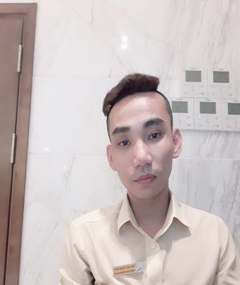

Birth: 28/05/1989

Add: 51/11b Sau Ga, Phuoc Tan, Nha trang

Tel: +84 822 992 690

E-mail: [tanhoangthien62@gmail.com](mailto:tanhoangthien62@gmail.com)

**Work Experience  
  
Apirl 2024 - Now: Bar Supervisor at Signature Hotel**Incharge Bar operation on duty shift, job assigment for collaborator, training new attendant and collaborator.

**February 2022 to 2023 - Now: Bar Supervisor at December Hotel**

Incharge Bar operation on duty shift, job assigment for collaborator, training new attendant and collaborator.

**From 2020 to 2022: Bar Supervisor Green Beach Hotel**

Head outlet of Bar team, incharge Restaurant and Bar incase head outlets are vacant.

**From 2019 to 2020: Bar Supervisor at Libra Hotel**

Incharge Bar operation on duty shift, job assigment for collaborator, training new attendant and collaborator.

**From 2018 to 2019: Bar Supervisor at Xavia Hotel**

Direct assistant of F&B manager, supervising station and job assigment for attendants.

**From 2015 to 2016: Bartender at Isena Hotel**

Prepare equipments and ingredient, serving guest order, support another outlets, training new attendant and collaborator.

**From 2013 to 2015: Bartender at Galina Hotel & Spa**

Prepare all the necessary equipments and ingredient, make a beverage follow the beverage order **Education**

Course 41 at 2016 – Yasaka Saigon NhaTrang Vocational Traning Center : Bartending Major

**Language**

Vietnamese - Native speaker, English - average

**Other skills**

Word, Excel, Power Point, Access

**Interests**

Dinking, Reading, Excercising.

**Reference**

Mr. Nguyen Huu Hoang - Food & Beverage Manager of December Hotel. Tel : 090 699 7544.

Mrs.Phan Thi Bich Huyen – Food & Beverage Manager of Green Bearch Hotel. Tel: 0818 077 883.