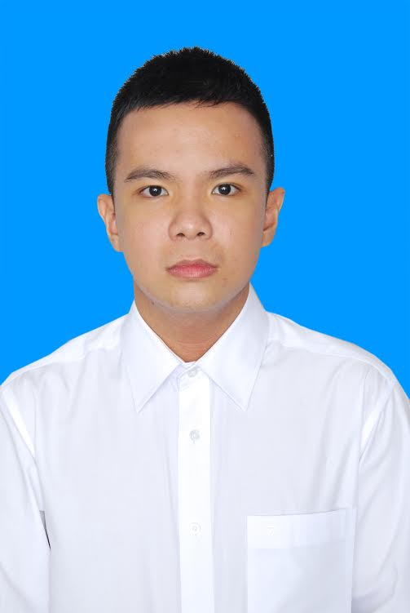

VÕ TRIỆU NGUYÊN

Mobile phone : 070.458.5026

E-mail : pinguyen2525@gmail.com
Single, 24 years old

EDUCATION

2013 – 2016 University of Technology - HUTECH - Ho Chi Minh City
Speciality in hospitality management industry includes hotel management, restaurant and catering services management, tourism service and travel management, event management.

PROFESSIONAL EXPERIENCES

Feb. 2016 – Aug.2016 Saigon Star Hotel - Ho Chi Minh City - Waiter
- Set up meeting room
- All Day Dining
- Room Service Attendent
Sept. 2016 – Dec. 2018 Bay Hotel – Ho Chi Minh City

Sept.2016 - Sept.2017 (Waiter)
- Room Dining Service
- Night Shift Attendant
- Banquest Attendant
Sept.2017 - Dec.2018 (Cashier)
- Cashier
Jan. 2019 – July.2019 Sai Gon Hotel
- Cashier

July.219 - Now EIGHT FOUR COLLECTIVE – IRUSU
- Cashier

LANGUAGE AND COMPUTER SKILLS
English Good working knowledge
Computer skills Proficient in Microsoft Office and Research on Internet
HOBBIES
Sport, martial arts, reading, listening to music, travelling and discovering new cultures.

